
FACULTY OF ENGINEERING
DIPLOMA ENGINEERING
DEPARTMENT OF COMPUTER ENGINEERING
SOFTWARE ENGINEERING (DE103304)

Unit–IV Software Coding and Testing

Coding
•The objective of coding phase is to transform the design of a system into code in a high-level language, and then to unit test this code.

Coding standards and guidelines
Coding Standard:
- Good software development organizations usually develop their own coding standards and guidelines depending on what suits their organizations best and based on the specific types of products they develop.
- Different modules specified in the design document are coded in the Coding phase according to the module specification.
- The main goal of the coding phase is to code from the design document prepared after the design phase through a high-level language and then to unit tests this code.
- Good software development organizations want their programmers to maintain to some welldefined and standard style of coding called coding standards.
- They usually make their own coding standards and guidelines depending on what suits their organization best and based on the types of software they develop.
- It is very important for the programmers to maintain the coding standards otherwise the code will be rejected during code review.
- Purpose of Coding Standards:
  - A coding standard gives a uniform appearance to the codes written by different engineers.
  - It improves readability, and maintainability of the code and it reduces complexity also.
  - It helps in code reuse and helps to detect error easily.
  - It promotes good programming practices and increases efficiency of the programmers.
  - It facilitates code understanding.
Coding Guidelines:
  - Do not use a coding style that is too clever or too difficult to understand.
  - Do not use an identifier for multiple purposes.
  - The code should be well-documented.
  - The length of any function should not exceed 10 source lines.
  - Do not uses GO TO statements.
- Characteristics of good coding :
  - It comes down to one programming principle
  - The Code Must Be Readable
  - The Code Must Be Scalable
  - The Code Must Be Testable.
  - The Code Does What Is Asked For
  - The Code Fails Gracefully
  - The Code Is Easy to Extend
  - The Code Is Reusable
Advantage of coding standard and guidelines:
- Coding standards help you develop less complex software and, therefore, reduce errors.
- Improvement of the bug fixing process: with coding standards, it becomes easier for developers to locate and correct bugs in the source code because it is written in a consistent manner.

Code Review
- Code review for a module is undertaken after the module successfully compiles.
- That is, all the syntax errors have been eliminated form the module.
- Eliminating an error from code involves three main activities – testing, debugging and then correcting the errors.
- Testing is carried out to detect if the system fails to work satisfactory for certain types of inputs and under certain circumstances.
- Once a failure is detected, debugging is carried out to locate the error that is causing the failure.
- Finally, error correction is carried out to fix the bug.
•Types of code review technique
  - Code Inspection
  - Code Walkthrough

Code Walkthrough
- Code walkthrough is an informal code analysis technique.
- In this technique, a module is taken up for review after the module has been coded, successfully compiled, and all syntax errors have been eliminated.
- A few members of the development team are given the code a couple of days before the walkthrough meeting.
- Each member selects some test cases and simulates execution of the code by hand.
- The main objective of code walkthrough is to discover the algorithmic and logical errors in the code.
- The members note down their findings of their walkthrough and discuss those in a walkthrough meeting where the coder of the module is present.
- Guidelines for Code Walkthrough techniques:
  - The team performing code walkthrough should not be either too big or too small. Ideally, it should consists of between three to seven members.
  - Discussions should focus on discovery of errors and avoid deliberations on how to fix the discovered errors.

Code Inspection
- During code inspection, the code is examined for the presence of some common programming errors.
- The principal aim of code inspection is to check for the presence of some common types of errors that usually creep into code due to programmer oversights and to check whether coding standards have been adhered to.
- Good software development companies collect statistics regarding different types of errors commonly committed by their engineers and identify the types of errors most frequently committed.
- Following is a list of some classical programming errors which can be checked during code inspection:
  - Use of uninitialized variables
  - Jumps into loops
  - Non-terminating loops
  - Incompatible assignments
  - Array indices out of bounds
  - Improper storage allocation and deallocation.
  - Mismatches between actual and formal parameter in procedure calls.
  - Improper modification of loop variables.

Software Documentation
- When a software product is developed, in addition to the executable files and the source code, several kinds of documents such as users’ manual, SRS document, design document, test document, installation manual etc. are developed as part of the software engineering process.
- Good documents are very useful and serve the following purposes.
  - Good documents help enhance understandability of a software product.
  - Documents help the users to understand an effectively use the system.
  - Good documents help in effectively tackling the manpower turnover problem.
- Different types of software documents can be classified into the following:
  - Internal Documentation:
    - These are provided in the source code itself.
  - External Documentation:
    - These are the supporting documents that usually accompany a software product.

Internal documentation
- Documentation which focuses on the information that is used to determine the software code is known as internal documentation.
- It describes the data structures, algorithms, and control flow in the programs.
- It includes header comment blocks and program comments.
- Header comment blocks are useful in identifying the purpose of the code along with details such as how the functions are used in the program. Since software code is updated and revised several times, it is important to keep a record of the code information so that internal documentation reflects the changes made to the software code.
- Internal documentation should explain how each code section relates to user requirements in the software.
- Generally, internal documentation includes the following information.
Name, type, and purpose of each variable and data structure used in the code
Brief description of algorithms, logic, and error-handling techniques Information about the required input and expected output of the program Information on the up gradations in the program.

External documentation
- It includes information such as function of code, name of the software developer who has written the code, dependency of code on programs, and format of the output produced by the software.
- Generally, external documentation describing the design of the program.
- It consists of information such as description of the problem along with the program written to solve it.
- It describes the approach used to solve the problem, operational requirements of the program, and user interface components.
- For the purpose of readability and proper understanding, the detailed description is given by figures and illustrations that how one component is related to another.
- External documentation explains why a particular solution is chosen and implemented in the software.
- It includes formulas, conditions, and references from where the documentation is derived.
- External documentation makes the user aware of the errors that occur while running thesoftware code. For example, if an array of five numbers is used, it should be mentioned in the external documentation that the limit of the array is five.

Testing Fundamentals
- The aim of program testing is to identify all defects in a program.
- However, in practice, even after satisfactory completion of the testing phase, it is not possible to guarantee that a program is error free.
- Terminologies of Testing
  - Error :An error is a mistake committed by the development team during any of the development phases.
  - Failure : A failure is the symptom of an error.
  - Test Case: A test case is the triplet[I,S,O], where I is the data input to the system, S is the state of the system at which the data is input, and O is the expected output of the system.
  - Test Suite : A test suite is the set of all cases with which a given software product is tested.
- Validation Vs Verification
  - Verification: Verification is the process of determining whether the output of one phase of software development conforms to that of its previous phase. Verification is Static Testing.
Activities involved in verification:
- Inspections
- Reviews
- Walkthroughs
- Desk-checking
✓Validation: Validation is the process of determining whether a fully developed system conforms to its requirement specification. Validation is the Dynamic Testing.
Activities involved in verification:
- Blackbox testing
- Whitebox testing
- Unit testing •Integration testing
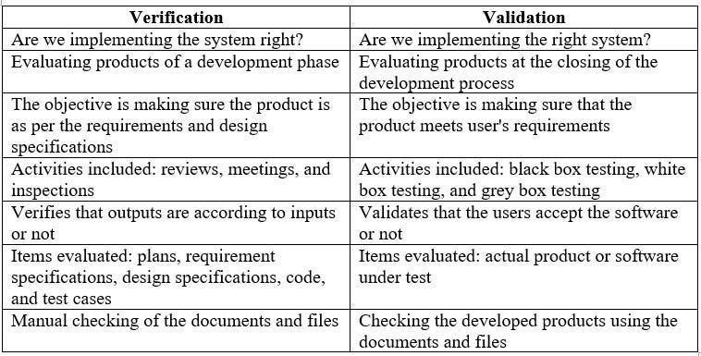

Testing Methods
There are two main approaches to design test cases:
- Black-box Approach
  - In the black-box approach, test cases are designed using only the functional specification of the software.
  - That is, test cases are designed solely based on an analysis of the input/output behavior and does not require any knowledge of the internal structure of a program.
  - For this reason, black-box testing is also known as functional testing.
- White-box Approach
  - In the white-box approach, designing white-box test cases requires a knowledge of the internal structure of a program, and therefore white-box testing is also called as structural testing.
  - In white-box approach, test cases are based on an analysis of the code.

Black-Box Testing (Functional Testing)
- In black-box testing, test cases are designed from an examination of the input/output values only and no knowledge of design or code is required.
- 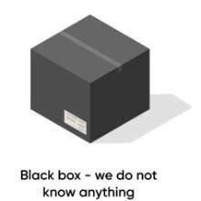

The following are the two main approaches available to design black-box test cases.
  - Equivalence Class Partitioning
  - Boundary Value AnalysisEquivalence Class Partitioning
- In the equivalence class partitioning approach, domain of input values to the program under test is partitioned into a set of equivalence classes.
The partitioning is done such that for every input data belonging to the same equivalence class, the program behaves similarly.
- Equivalence classes for a program can be designed by examining the input data and output data. •The following two general guidelines for designing the equivalence classes.
- If the input data values to a system can be specified by a range of values, then one valid and two invalid equivalence classes need to be defined. For example, if the equivalence class is the set of integers in the range 1 to 10, then the invalid equivalence classes are [-∞,0],[11,+∞].
- If the input data assumes values from a set of discrete members of some domain, then one equivalence class for the valid input values and another equivalence for the invalid input values should be defined. For example, if the valid equivalence classes are {A,B,C}, then the invalid class is U-{A,B,C}, where U is the universe of possible input values.
- Example, for a software that computes the square root of an input integer that can assume values in the range of 0 to 5000. Determine the equivalence class test suite.
- There are three equivalence classes- the set of negative integers, the set of integers in the range of 0 and 5000, and the set of integers larger than 5000.
- Therefore, the test cases must include representatives for each of the three equivalence classes.
- So, a possible test suite can be {-5,500,6000}.
Boundary value analysis
- A type of programming error that is frequently committed by programmers is missing out on the special consideration that should be given to the values at the boundaries of different equivalence classes of inputs.
- The reason behind programmers committing such errors might purely be due to psychological factors.
- Programmers often fail to properly address the special processing required by the input values that lie at the boundary of the different equivalence classes.
- For example, programmers may improperly use < instead of <= etc.
- Boundary value analysis-based test suite design involves designing test cases using the values at the boundaries of different equivalence classes.
For an equivalence class that is a range of values, the boundary values need to be included in the test suite.
- For example, if an equivalence class contain the integers in the range 1 to 10, then the boundary value test suite is {0,1,10,11}.

White-box testing (Structural Testing)
- White-box testing is an important type of unit testing.
- A large number of white-box testing strategies exist.
- Each testing strategy essentially designs test case based on analysis of some aspect of source code and is based on some heuristic.
- A white-box testing strategy can either be coverage-based or fault-based.
-  Coverage-based testing
  - A coverage-based testing strategy attempts to execute certain elements of a program.
  - Popular examples of coverage-base testing strategies are statement coverage, branch coverage and path coverage-based testing.
- Statement Coverage:
  - The statement coverage-based strategy aims to design test cases so as to execute every statement in a program at least once.
  - It is obvious that without executing a statement, it is difficult to determine whether it leads to a failure due to some illegal memory access, wrong result computation due to improper arithmetic operation, etc.
  - Example: Design statement coverage-based test suite for the following Euclid’s GCD computation program.
int computeGCD(int x,int y)
{
while(x!=y)
{
if(x>y) then
x=x-y; else y=y-x;
}
}
- To design the test cases for the statement coverage, the conditional expression of the while statement needs to be made true and the conditional expression of the if statement needs to be made both true and false.
- By choosing the test set { (x=3, y=3) , (x=4, y=3) , (x=3, y=4) } all statements of the program would be executed at least once.

- Branch Coverage:
  - Branch coverage-based testing requires test cases to be designed so as to make each branch condition in the program to assume true and false values in turn.
  - Branch testing is also known as edge testing, since in this testing scheme, each edge of a program’s control flow is traversed at least once.
  - For previous example, the test cases for branch coverage can be {(x=3, y=3), (x=3, y=2) , (x=4, y=3) , (x=3, y=4) }.
  - Branch coverage-based testing is a stronger testing than statement coverage-based testing.

- Path Coverage:
  - Path coverage-based testing strategy requires designing test cases such that all linearly independent paths in the program are executed at least once.
  - A linearly independent path can be defined in terms of the control flow graph(CFG) of a program.
  - A control flow graph describes how the control flows through the program.
  - In order to draw the flow graph of a program, we need to first number all the statements of a program.
  - The different numbered statements serve as nodes of the control flow graph.
  - There exists an edge from one node to another, if the execution of the statement representing the first node can result in the transfer of control to the other node.

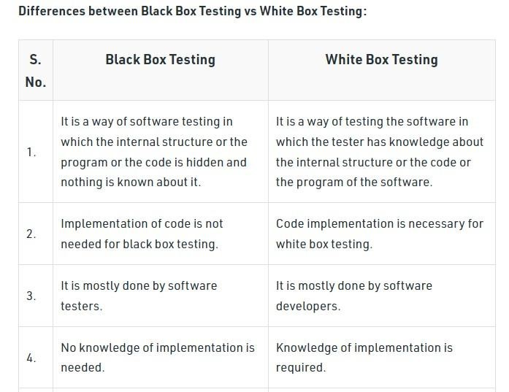  Overview of Alpha & Beta Testing
Alpha Testing:
Alpha testing is done internally by the development team in a controlled environment to find major issues.
Beta testing:

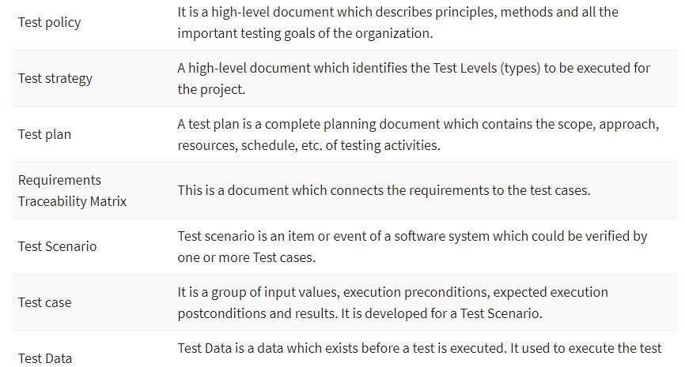 Types of Testing Documents

Advantages of Test Documentation
- The main reason behind creating test documentation is to either reduce or remove any uncertainties about the testing activities. Helps you to remove ambiguity which often arises when it comes to the allocation of tasks
- Documentation not only offers a systematic approach to software testing, but it also acts as training material to fresher’s in the software testing process
- It is also a good marketing & sales strategy to showcase Test Documentation to exhibit a mature testing process
- Test documentation helps you to offer a quality product to the client within specific time limits
- Test Documentation also helps to configure or set-up the program through the configuration document and operator manuals
- Test documentation helps you to improve transparency with the client
Disadvantages of Test Documentation
- The cost of the documentation may surpass its value as it is very time-consuming
- Many times, it is written by people who can’t write well or who don’t know the material •Keeping track of changes and updating corresponding documents is tiring.
- Poor documentation directly reflects the quality

Overview of Unit testing & Integration testing
- Unit Testing:
- Unit Testing is a type of software testing where individual software components are tested.
- Unit Testing of the software product is carried out during the development of an application.
- An individual component may be either an individual function or a procedure.
- Unit Testing is typically performed by the developer. It is a testing method using which every independent module are tested to determine if there is any issue by the developer himself.
- Integration Testing Integration testing is the process of testing the interface between two software units or modules.
- Its focus is on determining the correctness of the interface.
- Once all the modules have been unit tested, integration testing is performed.
Difference between Unit and Integration Testing:

Unit Testing | Integration Testing
In unit testing, each module of the software is tested separately. | In integration testing, all modules of the software are tested combined.
In unit testing tester knows the internal design of the software. | Integration testing doesn't know the internal design of the software.
Unit testing is the first level of Testing. | Integration testing is performed after unit testing and before system testing.
Unit testing is white box testing. | Integration testing is black box testing.
Unit testing is performed by the developer. | Integration testing is performed by the tester.
Unit testing is less costly. | Integration testing is more costly.

